BTWSC BRENT YOUTH SPOTLIGHT 2005 NOMINATION FORM
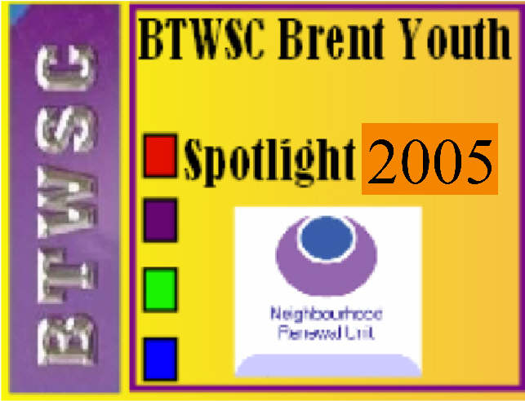
Please post to BTWSC, P O Box 14092, London NW10 1WL or email to info@btwsc.com. Closing date is June 30 2005.
Nomination form may be photocopied for multiple nominations. Also available at www.btwsc.com.

Name of nominee:

Age (13-17): Sex:  Male  Female School/college/workplace:

Address:

Telephone: Email:

School/College/Training or work place:

Ethnic background:

Name of person making nomination:

Relationship to nominee (e.g. parent, teacher, mentor, employer, friend, etc):

Address:

Telephone: Email:

Reason(s) for nomination:
(Please tick  achievement,  community/voluntary work,  exemplary behaviour,  courage, or
 turnaround from challenging behaviour; and write reasons below):

BYS GUIDANCE NOTES

- Nominees must be aged 13-17 years
- Nominees must be of Black and ethnic minority (BME) background
- Nominees must either live in Brent, or be registered in education, learning, training or work in Brent
- Nominees must be individuals. No group nominations accepted
- Individuals or organisations can nominate more than one person, but must use a separate nomination form for each nominee
- Person making nomination must inform nominees and their parents or carers of any submitted nominations, and must make them aware that, if short-listed, nominees, their parents or carers, the person who made nomination, and the nominee’s school/college/workplace will be invited to the award ceremony to be held Friday, 6.30-8.30pm July 2005 (date to be confirmed)
- Closing date for receipt of nominations forms (by post or email) is Monday June 30 2005
Following on from BTWSC's Newham Youth Spotlight 2003, and Brent Youth Spotlight 2004, BTWSC has been funded once again by Brent Neighbourhood Renewal Community Chest to run Brent Youth Spotlight 2005.
The aim is to highlight deserving black and ethnic minority (BME) youth doing positive things in the community, such as doing voluntary work, looking after disabled family members, running anti-bullying programmes; raise their self-esteem and confidence, and thereby encourage their peers to reach their full potential. The short-listed nominees will be recognised at a celebration and edu-tainment event on Friday July 2005 (date to be confirmed), 6.30-8.30pm. Special guest of honour is yet to be revealed!
Members of community organisations, schools, and the general public are invited to submit names of 13-17 year old Brent residents from BME backgrounds who deserve recognition for achievement, community work, exemplary behaviour, courage, or a turnaround from challenging behaviour.

